**Result analysis and feedback system**

Students take quizzes. System analyse it and give feedback with how much questions they get it right out of total. And show three areas the quiz taker got least mark as area of focus. More over detailed results will be given for example in each area, there are total number of questions and how many questions do the quiz taker get it right.

**Activity Diagram**

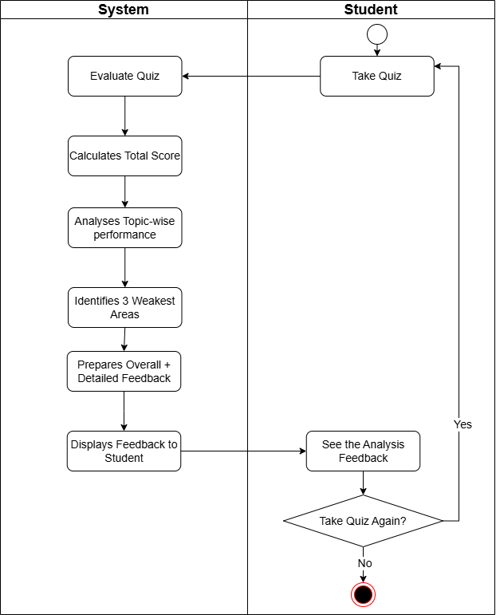

**UseCase Diagram**

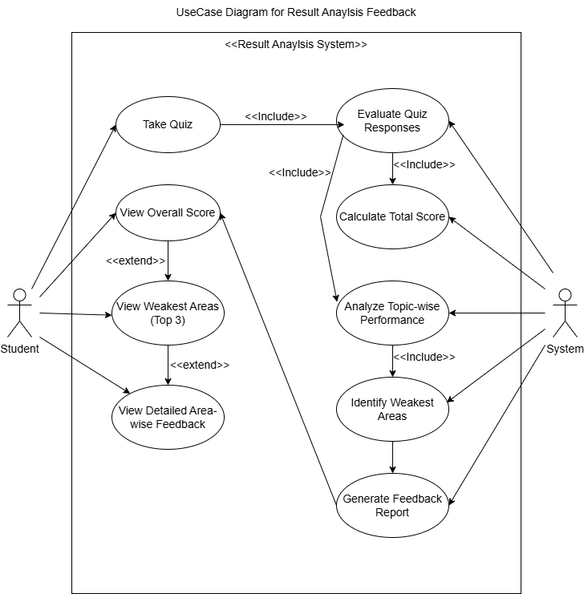

**Wireframe**

